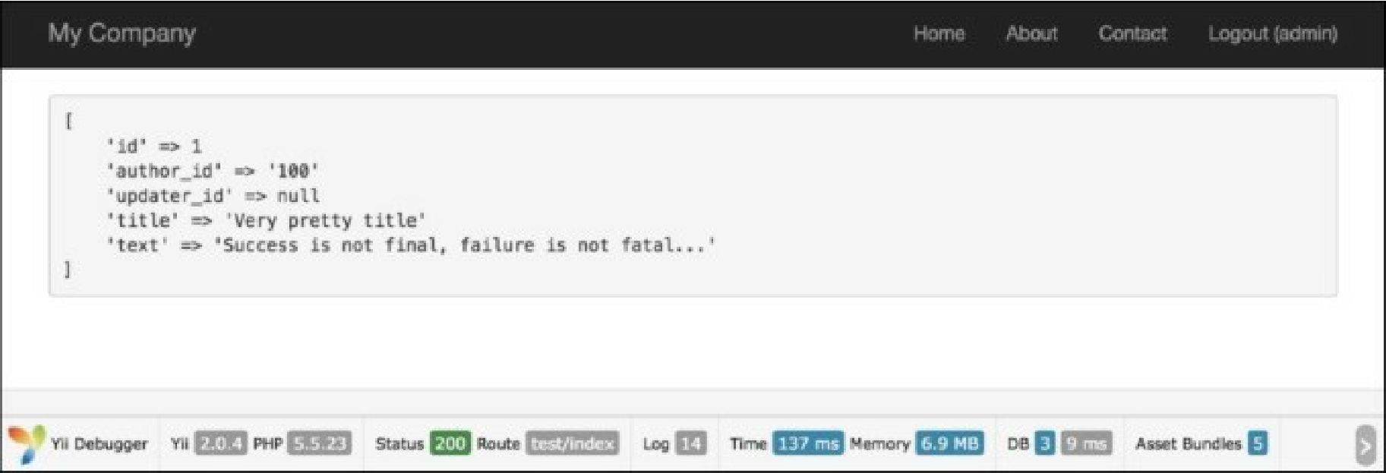

How it works...

By default, the Blameable behavior populates the created_by and updated_by attributes, but we will make a change and set up our behavior according to our own fields.

We also specified model events [and fields in the model, so, during the model creation, author_id will be](http://www.yiiframework.com/doc-2.0/yii-behaviors-blameablebehavior.html) populated. Similarly, during the model update, we will populate updater_id.

What Blameable does is insert the current user id value into the created_by and updated_by fields during the create/update model events. This is a super-convenient way of doing things. Every time a model gets created or updated, we automatically fill out the essential fields.

This works out really well for little projects such as for large systems, where multiple users are admin and you need to keep track of who is doing what. You can also use this for frontend implementations, for example, if you had a blog_comment table and you wanted to use this method to keep track of the author of a comment. Also, you could set the author’s fields in the controller, but the behavior helps you to avoid writing unnecessary and additional code. This is a very effective and easy way to implement this thing.

There’s more.

Sometimes we need to fill out author_id and updater_id by an id other than that of the current user. In such a case, we may detach our behavior as follows:

$model->detachBehavior('blammable ' );

We can detach any behavior we like in this way.

See also

For further information, refer to <http://www.yiiframework.com/doc-2.0/yii-behaviors->blameablebehavior.html